**NATIONAL UNIVERSITY OF SINGAPORE**

**CG5303: Intelligent Autonomous Robotic Systems**

**Lab: Dynamic modelling of robotic**

Appendix A: Simple Example 1

Simulation of Control Design for Assigned Systems

***1.1 Motion Control Design for Ground Vehicle***

In this part, the motion control problem is implemented for ground vehicle with model predictive control.

You are required to

* Establish the simulation environment using Simulink, which should clearly show the plant model part, controller part and input/output channel.
* Familiar with model predictive control method, given three state-space vehicle model for different control problem, like basic 2-DOF, 3DOF considering yawing moment and so on. Also explain the reason for such modeling.
* Realize the provided control algorithm on motion planning for ground vehicle and choose the suitable parameters,
* Use another control method or change the form of the optimal problem to compare the performance of these two different algorithms. Given and explain your observations.

***1.2 Required Software Platform***

In this project, you need to use Matlab and Simulink to realize software-in-the loop control. You need to familiar with basic language in Matlab coding (M language), basic block, like gain, scope, etc. in Simulink modeling and some specific functional blockset, like Vehicle Dynamics Blockset. Then you can realize some control algorithms by simulation.

You can use **Vehicle Dynamics Blockset** in Matlab/Simulink, which is only published in version from 2018a.The example model is established with version 2020b. So please install the suitable version on your computer. The detail of this blockset can be find in the Help Center, you can search to download the PDF documentation.

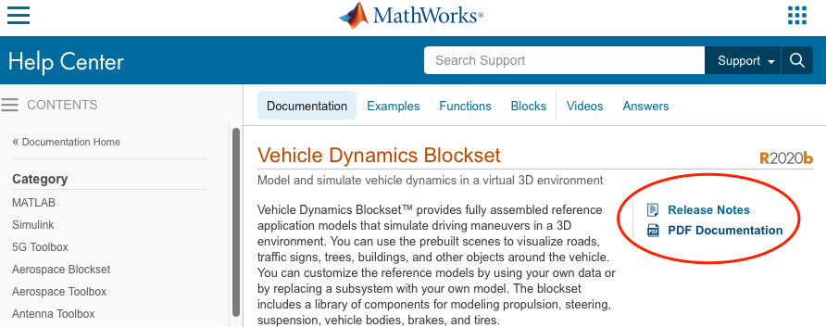

Fig1.1

***1.3 Simulation Model Establishment***

The model of ***Simulation*** is established in Matlab/Simulink. You can find the entrance in the highlight red square and create a blank model. Set parameters for this model.

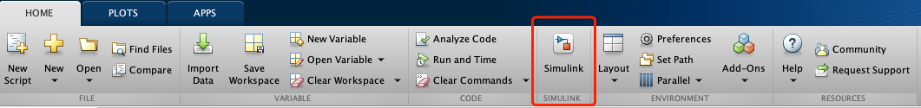

Fig1.2

Click Model Settings to set solver information.



Fig1.3

**Solver selection:** Type: Fixed-step / Solver: auto/ Fixed-step size: 0.01

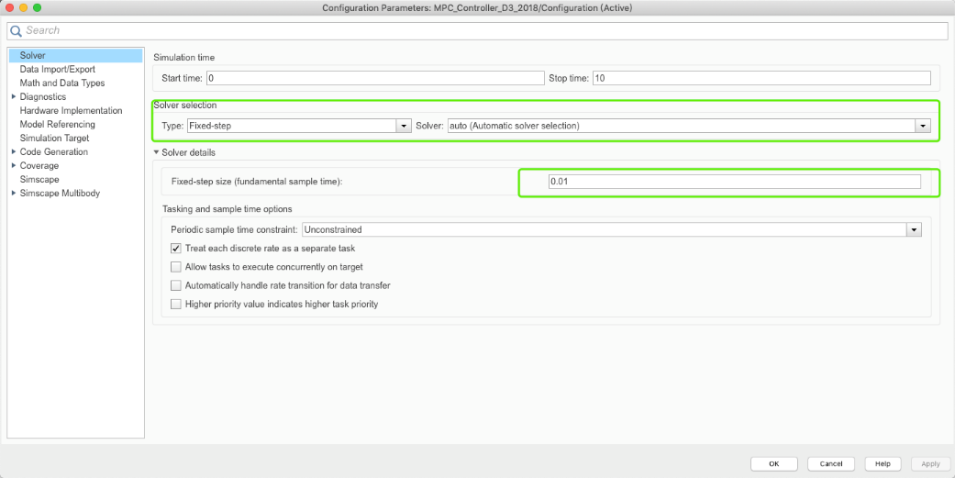

Fig 1.4

Here is an example to realize ground vehicle control.

The diagram of ***Simulation*** model is shown as follow.

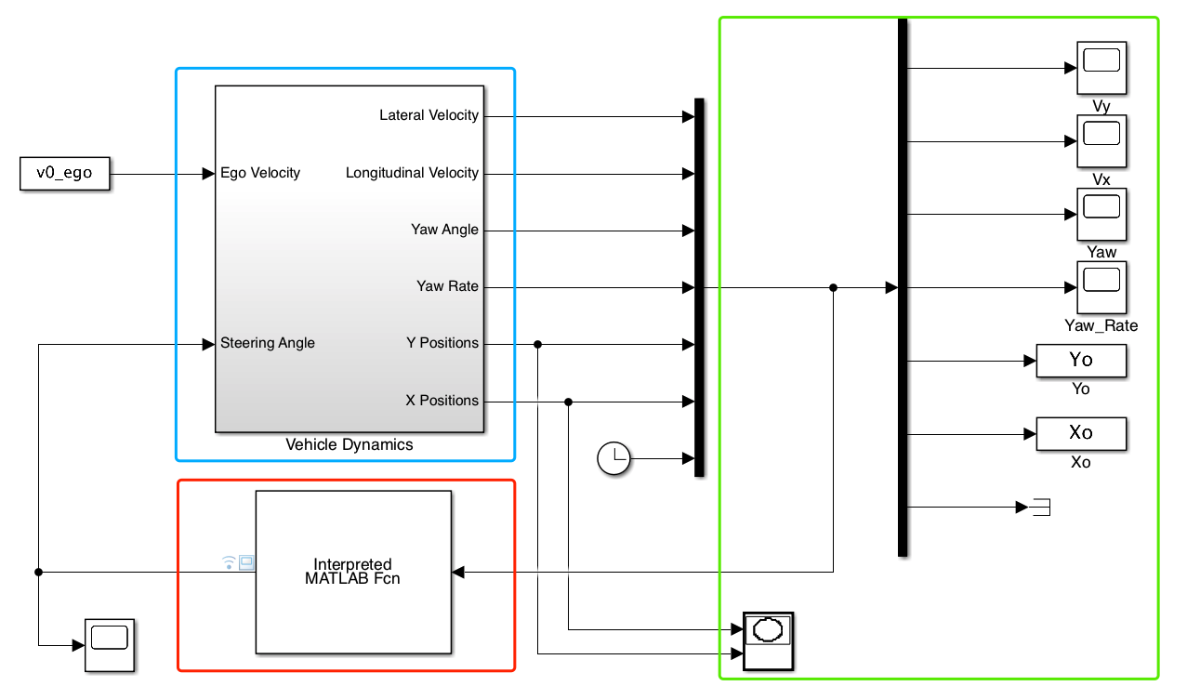

Fig 1.5

The area of red square is the controller. Use Interpreted MATLAB Fcn block, which can be found in Simulink Library Browser on the top of the interface.



Fig.1.6

Double click this block and assign the name of .m document for the coding of algorithm. In this example, we will use “MPC_controller.m”. Set Output dimensions to fit your algorithm.

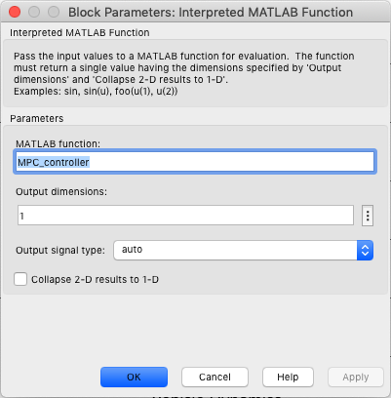

Fig 1.7

In the function, the example for input and output variable is

*function y = MPC_controller(x)*

*% input variable*

*vy=x(1); % lateral velocity， m/s*

*vx=x(2); % longitudinal velocity, m/s*

*fy=x(3); % Yaw angle，rad*

*wr=x(4); % Yaw rate rad/s*

*Y=x(5); % Y position， m*

*X=x(6); % X position，m*

*t=x(7); % Time, s*

*% main code*

*……*

*% output variable*

*y(1)=uu(1); % the output variable only contains 1 dimension; the example only use the first variable in the control horizon, uu is the whole optimized control sequence in MPC*

*end*

The area of green square is the scope to show the results of simulation. Use Scope block to show the simulation curve. Use To workspace block to save variables to the matlab workspace.

The area of blue square is the subsystem of plant model. The inside of blue square is shown as follow.

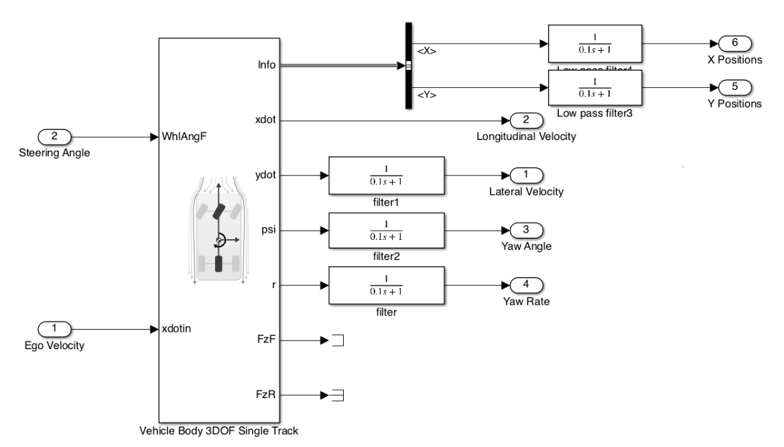

Fig 1.8

Use 3DOF Vehicle Body as the plant model from Vehicle Dynamics Blockset. All the blocks for Plant Model Establishment will be added from Simulink Library Browser.

If the signal fluctuates drastically, try to use **low pass filter** (as shown in the figure) and adjust the value of filter time constant and gain to obtain better performance.

Fig 1.9

The plant model has block option and vehicle parameters. Use external longitudinal velocity and Front wheel steering to set the model as a basic model. You can also try to add other options to obtain a more complicated plant model.

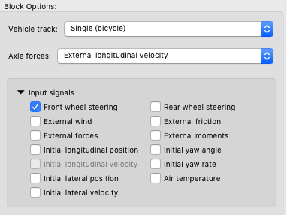

Fig 1.10

Here is an example about the main parameters of vehicle.

Table: vehicle parameters

|  |  |  |  |
| --- | --- | --- | --- |
| **Symbol** | **Description** | **Value** | **Unit** |
| $$M$$ | Vehicle mass | 1270 | kg |
| $$C_{f}$$ | Front tire corner stiffness | 1.4324e+05 | [N/rad]: |
| $$C_{r}$$ | Rear tire corner stiffness | 8.6517e+04 | [N/rad]: |
| $I_{z}$ ­ | Yaw polar inertia | 1536.7 | [kg*m^2] |
| $$l_{f}$$ | Longitudinal distance from center of mass to front axle | 1.015 | m |
| $$l_{r}$$ | Longitudinal distance from center of mass to rear axle | 1.895 | m |

Some output signal of the plant model subsystem that will use in algorithm design is summarized as

Table: output signal

|  |  |  |
| --- | --- | --- |
| **Source-Symbol** | **Description** | **Unit** |
| Info- InertFrm-Disp- $$X$$ | Vehicle CG displacement along the earth-fixed X-axis | m |
| Info- InertFrm-Disp- $$Y$$ | Vehicle CG displacement along the earth-fixed Y-axis | m |
| $xdot$ ­ | Vehicle CG velocity along the vehicle-fixed x-axis | m/s |
| $$ydot$$ | Vehicle CG velocity along the vehicle-fixed y-axis | m/s |
| $$psi$$ | Rotation of the vehicle-fixed frame about the earth-fixed Z-axis (yaw) | rad |
| $$r$$ | Vehicle angular velocity, r, about the vehicle-fixed *z*-axis (yaw rate) | rad/s |

Select these signals from the plant model.

Customized simulation model, set“v0_ego”with your desired velocity like 20m/s, and decide front wheel angle signal with step input, sin input signal or other input signal with appropriate value (best below 0.15 rad).

***1.4 Control Model Establishment***

For motion planning, there are two main characteristic, kinematic and dynamic, should be considered in the model of controller.

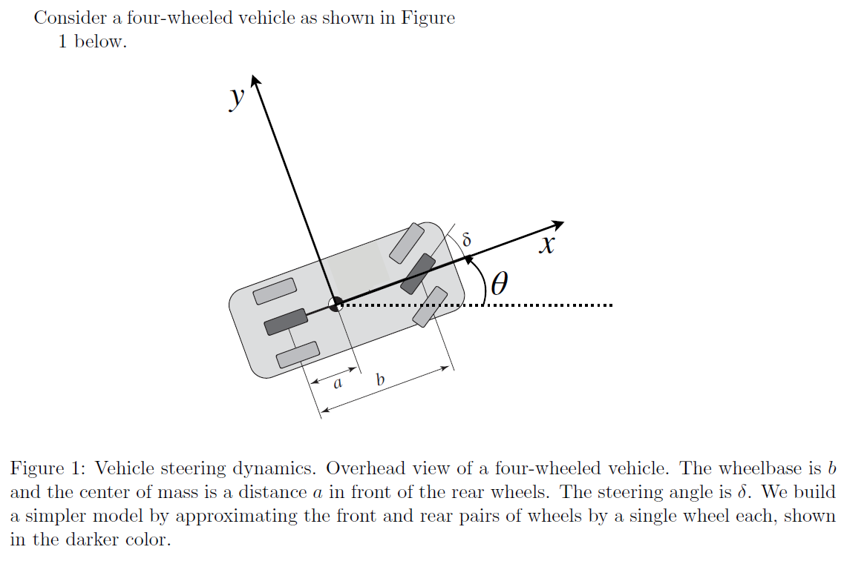

Fig 1.11

For the kinematic part, the equation can be expressed as



where $x_{G,}y_{G}$ is the coordinates of directions $X,Y$ in the global coordinate system; $v_{x}$ is the longitudinal velocity, $v_{y}$ is the lateral velocity, $θ$ is the heading angle in the global coordinate system; $ω_{r}$ is the yaw rate.

For the dynamic part, the equation can be expressed as



where $a_{x}={\dot{v}}_{x}-{ω_{r}v}_{y}$, $a_{y}={\dot{v}}_{y}+{ω_{r}v}_{x}$, $M$ is the mass of the vehicle; $w_{r}$ is the yaw rate; $I_{z}$ is the moment of inertia of the vehicle about the $z$-axis, and $l_{f}$ and $l_{r}$ are the distances from the center of gravity (CoG) to the front and rear axles, respectively; $F_{yf}$ and $F_{yr}$ are the lateral force with front and rear tires; $F_{xf}$ and $F_{xr}$ are the longitudinal force with front and rear tires,



$δ$ is the steering-wheel angle; $C_{f}$ and $C_{r}$ are the cornering stiffness values of the front and rear tires, respectively.

For simplification, the longitudinal velocity can be assumed as a constant. This is a simple example about ground vehicle model. There are also many complicate models can be used to establish controller.

***1.5 Control Algorithm Design and Coding***

The controller in this example is designed with model predictive control. The state-space model used in this example can be written as

The controller in this example is designed with model predictive control. The state-space model used in this example can be written as



This state-space model is a nonlinear model. For model predictive control, you can linearize the nonlinear model or directly discrete the model to formulate an optimal problem. Here, we directly discrete the model to formulate an optimal problem. The discrete time step is $d_{t}$. Then, the optimal control problem is to find the optimal control sequence $δ_{1},δ_{2},…., δ_{N}$ such that



You can code with Matlab to solve this optimal control problem with fmincon solver in Optimization Toolbox. Learn its function in help center of Matlab.

Fmincon is a nonlinear programming solver, which can find the minimum of a problem specified by

$\max_{x}{f(x)}$ such that $\left\{\begin{matrix}\begin{matrix}c(x)≤0 \\ ceq\left(x\right)=0\end{matrix} \\ \begin{matrix}A∙x≤b \\ Aeq∙x=beq\end{matrix} \\ lb≤x≤ub\end{matrix}\right.$

You need to initialize control variables values, which can be set as 0. Set the option for optimization and the objective function and constrainted fuction in separated functions, like ‘*myobj1*’, ‘*mycon1*’.

*u=ones(N,1)*0; % control variables--delta_f, N is the length of predictive horizon*

*options=optimset('Algorithm','interior-point','TolFun',1e-6,'LargeScale','on','MaxFunEvals',1e10, 'MaxIter',1e10);*

*[uu,fval,exitflag]=fmincon(@myobj1,u,[],[],[],[],[],[],@mycon1,options);*

In objective function, a example can be

*function f=myobj1(u)*

*global Ty M Izz lf lr dt xx vx N X % global variables*

*k1=0.2;k2=0.002;k3=0.2; %weights for optimization*

*f=k1*u(1)^2; % u^2+delta_u^2*

*for i=1:N-1*

*f=f+k1*u(i+1)^2+k3*(u(i+1)-u(i))^2;*

*end*

*shape=10; dx1=50; dx2=4; dy1=Ty; Xs1=2.3*vx;*

*vy0=xx(3,1); wr0=xx(4,1); fy_0=xx(2,1); s_y0=xx(1,1); X_predict=X;*

*for i=1:N*

*X_DOT=vx*cos(fy_0)-vy0*sin(fy_0);*

*X_predict=X_predict+X_DOT*dt;*

*z1=shape/dx1*(X_predict-Xs1)-shape/dx2;*

*Y_ref=dy1/2*(1+tanh(z1));*

*alpha1=-((vy0+lf*wr0)/vx-u(i))*180/pi;*

*alpha2=-(vy0-lr*wr0)/vx*180/pi;*

*Fy1=alpha1*1250;*

*Fy2=alpha2*755;*

*vy=vy0+(2*Fy2/M+2*Fy1/M-vx*wr0)*dt;*

*wr=wr0+(lf*2*Fy1/Izz-lr*2*Fy2/Izz)*dt;*

*fy=fy_0+wr0*dt;*

*sy=s_y0+vy0*cos(fy_0)*dt+vx*sin(fy_0)*dt;*

*vy0=vy; wr0=wr; fy_0=fy; s_y0=sy;*

*f=f+k2*(sy-Y_ref)^2; % calculate position error*

*end*

*end*

In constrainted function, a example can be

*function [c,ceq]=mycon1(u)*

*global N*

*u_lim=0.2;*

*c=ones(2*N,1); % inequlity eqution*

*for k=1:N*

*c(k)=u(k)-u_lim;*

*c(k+N)=-u(k)-u_lim;*

*end*

*ceq=zeros(4,1); % equlity eqution*

*end*

You can use global variables to store variables that don’t change during the solving process. An example can be

*global Ty M Izz lf lr dt xx N*

*% intalization*

*dt=0.05; % Discrete timestep, s*

*% vehicle parameters*

*M=1270; % vehicle mass, kg*

*Izz=1536.7; % moment of inertia of the vehicle*

*lf=1.015; % distance from the center of gravity to the front axles, m*

*lr=1.895; % distance from the center of gravity to the front axles, m*

*% before 2s lane-keeping with fix predictive horizon(1s), after 2s change lane*

*% in 3s with receding predictive horizon, after 5s lane-keeping with fix predictive horizon (1s)*

*T_lane_keep=1;*

*if t<2*

*tf=T_lane_keep;*

*Ty=0;*

*elseif t<5*

*tf=5-t;*

*Ty=4;*

*else*

*tf=T_lane_keep;*

*Ty=4;*

*end*

*N=max(round(tf/dt),round(T_lane_keep/dt)); %predictive horizon points*

*xx=zeros(4,1);*

*xx(1,1)=Y; xx(2,1)=fy; xx(3,1)=vy; xx(4,1)= wr;*

**Finish the control in Matlab/Simulink using this example. Use and compare the performance with different values of control parameters like “***k1,k2,k3***”, fix values and reference trajectory. Explain your observation.**

***1.6 Sample Model Usage Instruction***

For the usage of sample model that we offered, please open the main model “MPC_Controller.mdl”, then run parameter file “VehicleDynamicData.m”, and at last run the main model.